|  |
| --- |
| **NUCL 355 Experiment 2** |
| Reynold’s Experiment  Professor S. T. Revankar |
|  |
| School of Nuclear Engineering  Purdue University  Report of the Experiment By:  Weston Cundiff, Stephen Cox, Kara Luitjohan, Patrick Burk, Dominic Ghering, Michael Stryker, Austin Curtis, Matt Metzger, et. Al. |
| **Written By Alex Hagen** |
| **2/1/2011** |
|  |

# Introduction and Theory

Reynold’s Experiment is a simple and enlightening experiment to perform, describing many flow properties easily. The experiment itself is easily set up. The setup requires a water tower to provide a certain amount of static head. This should be easily adjustable so that different amounts of static head can be used for each pipe. An assortment of pipes must also be had, with a decent connection to the water tower. This is the element that the water will flow through, so there must be a way to keep this pipe level. A bucket and stopwatch must be kept, as a way to roughly time the flow rate. Also a set of calipers must be had to be able to characterize the entrance to the piping.

Using the water tower, water can be made to flow through each pipe at different rates. These rates can be taken using the bucket and stopwatch. Many different flow rates on different pipes must be taken to fully develop a relationship between the flow and it’s friction factor.

This lab can explain several concepts that are important in fluid dynamics, and those include the concepts of minor and major loss. The friction in the piping, which will be calculated after the experiment, is very important and makes up major loss. The loss of pressure through the exchanges in the piping, which will be calculated using the characterization of the entrance to the piping, will also create a large pressure drop. Without understanding of these two items, fluid dynamics would be very difficult.

Also important in this lab is the concept of laminar, turbulent, and transitional flow. A laminar flow case includes steamlined flow, with very few bubbles or eddies, whereas turbulent is exactly the opposite of this. The ink allowed to flow in the steam is a visual way of characterizing this, but the Reynold’s number, which will be calculated after the experiment, is a numerical way to categorize the flow.

# Analysis and Discussion of Data

The analysis of the data acquired in this lab is centered around one main goal, to determine the friction factor developed in the tube under different flow conditions. With this data, the friction factor can be graphed against the Reynold’s number of the flow created under those conditions and this chart can be compared to previously created curves for this relationship. The name of this graphical representation of this data is called the Moody Chart, and it clearly shows the relationship between the two dimensionless parameters. A typical Moody chart is shown below:

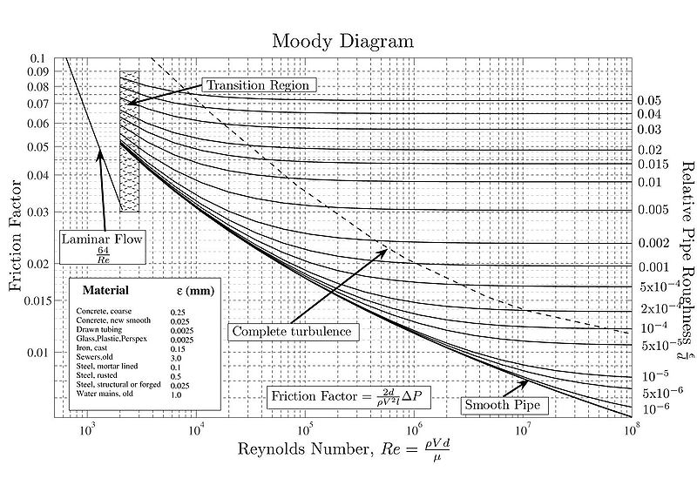

Figure .1 The Moody Chart

The process to be able to chart the Moody Diagram from the experiment created is no small task. The steps have been described here and also shown explicitly under the Sample Calculations Appendix of this report. First, the volumetric flowrate must be found, and from that the velocity of the flow can be found. Using the static head of the water column at the beginning of flow, and the dynamic head at the bucket, the loss across the entire length of the tube can be calculated. The difference between the static and dynamic head can all be attributed to major and minor losses.

Because the geometry of the connection between the tank and the piping has been characterized, it is possible for the minor loss to be calculated directly. The Munson and Young textbook includes two charts that help determine the minor loss coefficient, both for conical diffusers and rounded entrances. The charts are shown below:

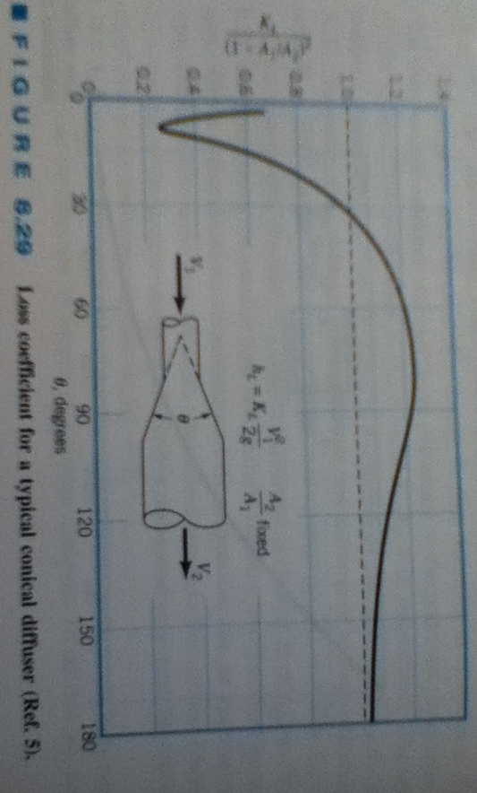

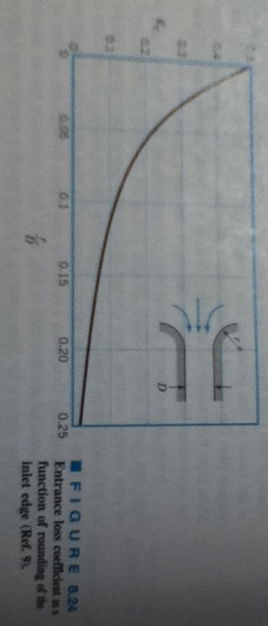

Figure .2 Figures from Munson Textbook

After the minor loss coefficients are calculated, the amount of minor loss can be tabulated. With the static head, the dynamic head, and the minor loss, all parts of the pressure have been accounted for with exception of the major head. Using the remainder of the pressure as the major loss, a value for the major loss can be used for each different flow situation.

With the major loss, the friction factor can start to be calculated. The major loss depends on the dynamic head of the fluid as well as the pipe dimensions (length and diameter) all multiplied by the friction factor. Solving for the one unknown, the friction factor can be solved in all flow situations. Upon inspection, values looked correct, being small decimal values, and dimensionless. The Reynold’s Number is also calculated with variable calculated while developing the friction factor. The Moody Chart created by this analysis is shown below:

When compared to the values on an accepted Moody Chart, the curves on this Moody chart seem to fit the general shape theoretically described, but some of the values are way off. The Moody Chart shown above shows that no value reaches above .1 for the friction factor, whereas the one created from this experiment includes every point from Tube Rough above .1 for friction factor. This is possibly because the rough tube had more losses based on the roughness of the tube. The friction factor should be much higher because of these macroscopic defects of in the pipe wall, artificially raising the friction factor.

# Conclusions

The conclusions from this experiment can be characterized into three categories.

The first and most important conclusions that can be drawn have to do with the fit of the tested flow cases to the Moody Chart. The Moody Chart that was created using the friction factors and Reynold’s Numbers that were calculated in the experiment. The Reynold’s Numbers ranged from 0 all the way to 16000, as expected, and the friction factor ranged from close to 0 all the way up to .140. The shape of these curves fits the exponential decay curves that is shown on typical moody charts.

The second important conclusion also has to do with the Moody Chart. In a typical Moody Chart, no friction factor reaches above .100. In the one created by this experiment, one certain tube had values that were well above this value, up to almost .140. After inspection of the pipe that created this range of values, it was obvious why this occurred. This pipe had physical and visible defects in its pipe inner surface of diameter of about .07cm. These grains are big enough to cause a huge effect on the friction factor inside the tube. This conclusions shows that the friction factor does increase with increasing roughness of the pipe surface, as it theoretically should. The conclusion also states that visual inspection of tubes can allow for better analysis of flow parameters, and that typical Moody Charts show only smooth pipes.

The third conclusion is a simple conclusion about characterizing the flow of systems. Ink was used in the experiment for a visual inspection way of characterizing the flow as laminar, transitional, or turbulent. A turbulent flow would barely show the ink after it entered the flow because it would be tossed around so much with would become invisible. The laminar flow showed a long streamline of ink, and the transitional was somewhere in between. These are also easy to make using the values of the Reynold’s Number, and there are certain guidelines for doing this. The Reynold’s number did match the visual inspection for every tube that was inspected, again showing that the Reynold’s number and other mathematical methods are effective ways to characterize flow.

# Works Cited

Beck, S., & Collins, R. (2008). *Moody Chart.* Sheffield, UK: University of Sheffield.

Munson, Y. O. (2009). *Fundamentals of Fluid Mechanics.* Hoboken, NJ: Wiley and Sons, Inc.

Revankar, S. (2011). *Experiment #2: Reynolds Experiment.* West Lafayette, IN: Purdue University School of Nuclear Engineering.

# Appendices

## Original Data

|  |  |  |  |  |  |
| --- | --- | --- | --- | --- | --- |
| Tube 4 | Flow | Entrance Length (cm) | Tank Level (inches) | Collected Water (L) | Time (sec) |
|  | Laminar | N/A | 0.375 | 2 | 96.84 |
|  | Laminar | N/A | 0.375 | 2 | 93.95 |
|  | Laminar | N/A | 0.375 | 1 | 43.28 |
|  | Laminar | N/A | 0.375 | 1 | 44.22 |
|  | Transitional | N/A | 3.25 | 1 | 10.71 |
|  | Transitional | N/A | 3.25 | 1 | 9.76 |
|  | Transitional | N/A | 3.25 | 1 | 9.56 |
|  | Transitional | N/A | 3.25 | 1 | 9.83 |
|  | Transitional | N/A | 3.25 | 1 | 10.42 |
|  | Turbulent | 3.25 | 6.625 | 2 | 16.36 |
|  | Turbulent | 3.25 | 6.625 | 2 | 15.96 |
|  | Turbulent | 3.25 | 6.625 | 2 | 15.28 |
|  | Turbulent | 3.25 | 6.625 | 2 | 15.47 |
|  | Turbulent | 3.25 | 6.625 | 2 | 15.40 |
|  | Turbulent | 2.5 | 9.0625 | 2 | 14.18 |
|  | Turbulent | 2.5 | 9.0625 | 2 | 14.17 |
|  | Turbulent | 2.5 | 9.0625 | 2 | 13.22 |
|  | Turbulent | 2.5 | 9.0625 | 2 | 13.44 |
|  | Turbulent | 2.5 | 9.0625 | 2 | 13.53 |

Table .1 Tube 4 Trial

|  |  |  |  |  |  |
| --- | --- | --- | --- | --- | --- |
| Tube Rough | Flow | Entrance Length (cm) | Tank Level (inches) | Collected Water (L) | Time (sec) |
|  | Laminar | N/A | 0.375 | 1 | 63.13 |
|  | Laminar | N/A | 0.375 | 1 | 66.03 |
|  | Laminar | N/A | 0.375 | 1 | 65.33 |
|  | Turbulent | 20.67 | 3.25 | 1 | 21.43 |
|  | Turbulent | 20.67 | 3.25 | 1 | 19.45 |
|  | Turbulent | 20.67 | 3.25 | 1 | 20.82 |
|  | Turbulent | 20.67 | 3.25 | 1 | 20.06 |
|  | Turbulent | 20.67 | 3.25 | 1 | 20.70 |
|  | Turbulent | 3.75 | 6.5 | 2 | 33.55 |
|  | Turbulent | 3.75 | 6.5 | 2 | 33.19 |
|  | Turbulent | 3.75 | 6.5 | 2 | 33.35 |
|  | Turbulent | 3.75 | 6.5 | 2 | 34.15 |
|  | Turbulent | 3.75 | 6.5 | 2 | 33.98 |
|  | Turbulent | 2.77 | 9.125 | 2 | 27.83 |
|  | Turbulent | 2.77 | 9.125 | 2 | 28.24 |
|  | Turbulent | 2.77 | 9.125 | 2 | 27.64 |
|  | Turbulent | 2.77 | 9.125 | 2 | 28.33 |

Table .2 Tube Rough Trial

|  |  |  |  |  |  |
| --- | --- | --- | --- | --- | --- |
| Tube 5 | Flow | Entrance Length (cm) | Tank Level (inches) | Collected Water (L) | Time (sec) |
|  | Laminar | N/A | 0.25 | 1 | 63.43 |
|  | Laminar | N/A | 0.25 | 1 | 63.40 |
|  | Transitional | 37 | 3.25 | 2 | 26.32 |
|  | Transitional | 37 | 3.25 | 2 | 25.61 |
|  | Transitional | 37 | 3.25 | 2 | 25.21 |
|  | Transitional | 37 | 3.25 | 2 | 25.37 |
|  | Transitional | 37 | 3.25 | 2 | 26.05 |
|  | Turbulent | 16 | 6.4375 | 2 | 18.11 |
|  | Turbulent | 16 | 6.4375 | 2 | 17.95 |
|  | Turbulent | 16 | 6.4375 | 2 | 17.67 |
|  | Turbulent | 9 | 9.0625 | 2 | 14.18 |
|  | Turbulent | 9 | 9.0625 | 2 | 14.62 |
|  | Turbulent | 9 | 9.0625 | 2 | 14.33 |

Table .3 Tube 5 Trial

|  |  |  |  |  |  |
| --- | --- | --- | --- | --- | --- |
| Tube 2 | Flow | Entrance Length (cm) | Tank Level (inches) | Collected Water (L) | Time (sec) |
|  | Laminar | N/A | 0.375 | 0.25 | 58.24 |
|  | Laminar | N/A | 0.375 | 0.25 | 59.83 |
|  | Laminar | N/A | 3.25 | 0.5 | 28.53 |
|  | Laminar | N/A | 3.25 | 0.5 | 26.70 |
|  | Laminar | N/A | 3.25 | 0.5 | 27.82 |
|  | Laminar | N/A | 6.375 | 1 | 38.51 |
|  | Laminar | N/A | 6.375 | 1 | 38.40 |
|  | Laminar | N/A | 6.375 | 1 | 39.36 |
|  | Laminar | N/A | 9.125 | 1 | 36.86 |
|  | Laminar | N/A | 9.125 | 1 | 34.73 |
|  | Laminar | N/A | 9.125 | 1 | 35.12 |

Table .4 Tube 2 Trial

|  |  |  |  |  |  |  |  |  |  |
| --- | --- | --- | --- | --- | --- | --- | --- | --- | --- |
|  |  |  | Pressure 1 (4.3cm) | Pressure 2 (10.6cm) | Pressure 3(16.9cm) | Pressure 4 (29.6cm) | Pressure 5 (42.3cm) | Pressure 6 (67.8cm) | Pressure 7 (93.0cm) |
| Tank Level (inches) | **Collected Water (L)** | **Time (sec)** | **height (cm)** | **height (cm)** | **height (cm)** | **height (cm)** | **height (cm)** | **height (cm)** | **height (cm)** |
| 0.375 | 1 | 34.37 | 1.0 | 0.9 | 0.9 | 0.8 | 0.6 | 0.0 | 0.0 |
| 0.375 | 1 | 32.98 |  |  |  |  |  |  |  |
| 0.375 | 1 | 33.99 |  |  |  |  |  |  |  |
| 3.25 | 2 | 24.65 | 5.5 | 5.2 | 4.9 | 4.3 | 3.7 | 2.4 | 1.0 |
| 3.25 | 2 | 23.80 |  |  |  |  |  |  |  |
| 3.25 | 2 | 23.71 |  |  |  |  |  |  |  |
| 6.4375 | 2 | 17.83 | 11.0 | 10.5 | 9.9 | 8.7 | 7.5 | 4.6 | 2.1 |
| 6.4375 | 2 | 17.10 |  |  |  |  |  |  |  |
| 6.4375 | 2 | 16.97 |  |  |  |  |  |  |  |
| 6.4375 | 2 | 16.88 |  |  |  |  |  |  |  |
| 9.0625 | 2 | 14.25 | 15.2 | 14.5 | 14.0 | 12.1 | 10.5 | 6.4 | 3.0 |
| 9.0625 | 2 | 13.93 |  |  |  |  |  |  |  |
| 9.0625 | 2 | 14.14 |  |  |  |  |  |  |  |
| 9.0625 | 2 | 14.15 |  |  |  |  |  |  |  |
| 9.0625 | 2 | 14.27 |  |  |  |  |  |  |  |

Table .5 Pressure Drop Trial

|  |  |  |  |  |  |
| --- | --- | --- | --- | --- | --- |
| Tube | Entrance diameter (in) | Entrance depth (in) | Pipe diameter (in) | Length (in) | Grain size (in) |
| 1 (Rough) | 0.889 | 0.290 | 0.489 | 47.1250 | 0.027 |
|  | 0.901 | 0.336 | 0.496 | 47.1875 | 0.030 |
|  | 0.898 | 0.331 | 0.495 | 47.1250 | 0.026 |
|  |  | 0.315 | 0.488 |  |  |
| 2 | 0.782 | 0.727 | 0.248 | 53.0625 |  |
|  | 0.779 | 0.786 | 0.249 | 53.1250 |  |
|  | 0.797 | 0.724 | 0.250 | 53.1250 |  |
| 3 | 0.662 | 0.726 | 0.735 | 48.1250 |  |
|  | 0.645 | 0.710 | 0.745 | 48.0625 |  |
|  | 0.630 | 0.720 | 0.750 | 48.1875 |  |
| 4 | 0.907 | 0.397 | 0.496 | 46.7500 |  |
|  | 0.914 | 0.412 | 0.492 | 46.8125 |  |
|  | 0.920 | 0.408 | 0.498 | 46.7500 |  |
| 5 | 0.982 | 0.440 | 0.495 | 50.1250 |  |
|  | 0.962 | 0.441 | 0.499 | 50.3125 |  |
|  | 0.959 | 0.460 | 0.496 | 50.1250 |  |
| with pressure things attached | 1.488 | 0.379 | 0.492 | 48.4251 |  |
|  | 1.455 | 0.401 | 0.494 |  |  |
|  | 1.489 | 0.406 | 0.496 |  |  |

Table .6 Tube Measurements Table

## Reduced Data

|  |  |  |  |  |  |
| --- | --- | --- | --- | --- | --- |
| Tube | Entrance Diameter (cm) | Entrance Depth (cm) | Pipe Diameter (cm) | Length (cm) | Grain Size (cm) |
| 1 (Rough) | 0.353 | 0.125 | 0.194 | 18.5614 | 0.010892 |
| 2 | 0.309 | 0.294 | 0.098 | 20.9072 |  |
| 3 | 0.254 | 0.283 | 0.293 | 18.9469 |  |
| 4 | 0.360 | 0.160 | 0.195 | 18.4137 |  |
| 5 | 0.381 | 0.176 | 0.196 | 19.7589 |  |
| with pressure things attached | 0.582 | 0.156 | 0.194 | 19.0650 |  |

Table .7 Reduced Tube Measurements Table

|  |  |  |
| --- | --- | --- |
| Tube 4 | Friction Factor | Reynold's Number |
|  | 0.055 | 2090.04 |
|  | 0.051 | 2154.33 |
|  | 0.040 | 2338.25 |
|  | 0.043 | 2288.55 |
|  | 0.013 | 9449.08 |
|  | 0.008 | 10368.81 |
|  | 0.007 | 10585.73 |
|  | 0.009 | 10294.98 |
|  | 0.012 | 9712.05 |
|  | 0.019 | 12371.59 |
|  | 0.017 | 12681.66 |
|  | 0.015 | 13246.02 |
|  | 0.015 | 13083.34 |
|  | 0.015 | 13142.81 |
|  | 0.020 | 14273.57 |
|  | 0.020 | 14283.64 |
|  | 0.015 | 15310.08 |
|  | 0.016 | 15059.47 |
|  | 0.017 | 14959.29 |

Table .8 Reduced Data for Tube 4

|  |  |  |
| --- | --- | --- |
| Tube 5 | Friction Factor | Reynold's Number |
|  | 0.067 | 1591.17 |
|  | 0.067 | 1591.92 |
|  | 0.033 | 7669.30 |
|  | 0.030 | 7881.92 |
|  | 0.029 | 8006.98 |
|  | 0.030 | 7956.48 |
|  | 0.032 | 7748.79 |
|  | 0.030 | 11146.1 |
|  | 0.029 | 11245.45 |
|  | 0.028 | 11423.65 |
|  | 0.025 | 14235.25 |
|  | 0.027 | 13806.83 |
|  | 0.025 | 14086.24 |

Table .9 Reduced Data for Tube 5

|  |  |  |
| --- | --- | --- |
| Tube Rough | Friction Factor | Reynold's Number |
|  | 0.101 | 1613.90 |
|  | 0.112 | 1543.01 |
|  | 0.109 | 1559.55 |
|  | 0.100 | 4754.33 |
|  | 0.080 | 5238.32 |
|  | 0.094 | 4893.62 |
|  | 0.086 | 5079.03 |
|  | 0.093 | 4921.99 |
|  | 0.127 | 6073.64 |
|  | 0.124 | 6139.51 |
|  | 0.125 | 6110.06 |
|  | 0.132 | 5966.93 |
|  | 0.131 | 5996.78 |
|  | 0.122 | 7321.97 |
|  | 0.126 | 7215.67 |
|  | 0.120 | 7372.30 |
|  | 0.127 | 7192.75 |

Table .10 Reduced Data for Tube Rough

|  |  |  |
| --- | --- | --- |
| Tube 2 | Friction Factor | Reynold's Number |
|  | 0.038 | 864.16 |
|  | 0.040 | 841.20 |
|  | 0.015 | 3528.14 |
|  | 0.012 | 3769.95 |
|  | 0.014 | 3618.18 |
|  | 0.013 | 5227.61 |
|  | 0.012 | 5242.59 |
|  | 0.013 | 5114.72 |
|  | 0.019 | 5461.62 |
|  | 0.016 | 5796.59 |
|  | 0.017 | 5732.22 |

Table .11 Reduced Data for Tube 2

## Sample Calculations

### Volumetric Flow Rate

$$Q=\frac{Liters Filled}{Time Taken To Fill}=\left(\frac{1L}{96.84s}\right)=0.02\frac{L}{s}$$

### Flow Velocity

$$Q=AV$$

$$V=\frac{Q}{A}=\frac{Q}{π*{\left(\frac{D}{2}\right)}^{2}}=\frac{4Q}{π*D^{2}}=\frac{4*\left(0.02\frac{L}{s}\right)}{π*{\left(1.257 cm\right)}^{2}}=0.1661\frac{m}{s}$$

### Static Head

$$p_{static}=ρ*g*h=\left(1000\frac{kg}{m^{3}}\right)\left(9.81\frac{m}{s^{2}}\right)\left(0.009525 m\right)=93.44025 Pa$$

### Dynamic Head

$$p_{dynamic}=\frac{ρV^{2}}{2}=\frac{\left(1000\frac{kg}{m^{3}}\right){\left(0.1661\frac{m}{s}\right)}^{2}}{2}=13.794 Pa$$

### Angle in Conical Diffuser

$$θ=2*\frac{180}{π}*\arctan\left(\frac{D_{2}-D_{1}}{L}\right)=2*\frac{180}{π}*\arctan\left(\frac{2.276 cm-1.250 cm}{0.808 cm}\right)={103.585}^{o}$$

### r/D for Curved Entrance Tubes

$$\frac{r}{D}=\frac{L}{4*Average\left(D_{1},D_{2}\right)}=0.153$$

### (1-A2/A1)^2

$${\left(1-\frac{A_{2}}{A_{1}}\right)}^{2}={\left(1-\frac{D_{2}^{2}}{D_{1}^{2}}\right)}^{2}={\left(1-\frac{{\left(1.250 cm\right)}^{2}}{{\left(2.276 cm\right)}^{2}}\right)}^{2}=0.488$$

### Minor Loss

$$∆p_{minor}=K_{L}\frac{ρV^{2}}{2}=0.561 \left(\frac{\left(1000\frac{kg}{m^{3}}\right){\left(.1661\frac{m}{s}\right)}^{2}}{2}\right)=8.25 Pa$$

### Major Loss

$$∆p_{major}=p_{static}-p_{dynamic}-p_{minor}=93.44025 Pa-13.79798 Pa-8.254916 Pa=71.38735 Pa$$

### Friction Factor

$$∆p_{major}=f\frac{l}{D}\left(\frac{{ ρV}^{2}}{2}\right)$$

$$f= \frac{2∆p_{major}D}{lρV^{2}}=\frac{2\left(71.38735 Pa\right)\left(.01258 m\right)}{\left(1.187979 m\right)\left(1000\frac{kg}{m^{3}}\right){\left(0.1661\frac{m}{s}\right)}^{2}}=0.054793$$

### Reynolds number

$$Re=\frac{ρVd}{μ}=\frac{\left(1000\frac{kg}{m^{3}}\right)\left(0.1661\frac{m}{s}\right)\left(0.01258 m\right)}{1.003*{10}^{-3}} \left[dimensionless quantity\right]=$$